Guest Faculty

Carla Lamb
Director of Interventional Pulmonology Lahey Clinic, Boston, Massachusetts, USA

Gary Lee
Professor of Respiratory Medicine, University of Western Australia.

Benjamin Kwan
Consultant and Head, Respiratory and Sleep Medicine, Sutherland Hospital, Australia

Local Faculty
Lee Pyng, Course Director
Associate Professor
Director of Interventional Pulmonology National University Hospital

T. Agasthian,
Associate Professor, Thoracic Surgery

Cheah Foong Koon
Senior Consultant, Thoracic Imaging, Singapore General Hospital

Seet Ju Ee
Senior Consultant, Diagnostic Pathology National University Hospital

Teoh Chia Meng
Senior Consultant, National University Hospital

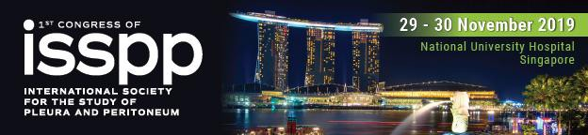
Pleura and Pleuroscopy
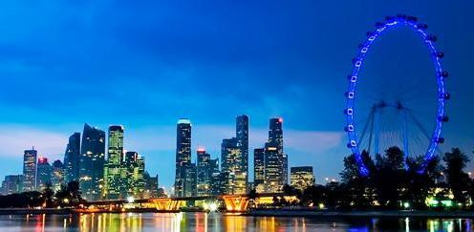

Course description
State of the Art Review on Imaging, Diagnosis, and Treatment of Pleura Diseases. Role of Biomarkers to facilitate diagnosis, Thoracic Ultrasound for diagnosis and guide pleural procedures, Pleuroscopy, chest drains and indwelling pleural catheters for pleural diseases, Pathology of pleural diseases are topics that will be of interest to internists, pulmonologists, surgeons, medical oncologists, and pathologists. The course features lectures followed by “hands-on” experience.
Who should attend
Specialists, trainees in Pulmonary Medicine, Oncology, Thoracic Surgery, Pathology and researchers with interest in pleural diseases.

ASTC, National University Hospital, Kent Ridge Level 2
28 Nov 2019 Registration: 7:30 - 8:30am
8:30-8:40 Opening Remarks. Lee Pyng, NUH
8:45-9:15 Diagnostic Approach to Pleural Effusion. Gary Lee, Australia 9:15-9:45 Imaging of Pleura. Cheah Foong Koon, SGH

9:45-10:00 COFFEE BREAK
10-10:30 Ultrasonography of Lung and Pleura. Ben Kwan, Australia 10:30-11:00 Malignant Pleural Effusion. Carla Lamb, USA
11-11:30 Pneumothorax. Gary Lee, Australia 11:30-12 Pleural Infection. Carla Lamb, USA
12-12:30 Pleural Procedures and Pleuroscopy. Lee Pyng, NUH 12:30-1 Pleural Pathology. Seet Ju Ee, NUH

1-2pm LUNCH Symposium
1-1:30pm: Recent advances in Mesothelioma: Gary Lee, Australia 1:30-2pm Surgery for Mesothelioma. T Agasthian

2-5pm HANDS-ON PRACTICE:
Thoracic Ultrasound 2 stations: Ben Kwan, Teoh Chia Meng

Indwelling Pleural Catheters 2 stations: Carla Lamb (Pleurx), Gary Lee (Rocket)

Pleuroscopy 1 station: Lee Pyng Cryobiopsy of pleura 1 station: Erbe
6pm bus pick up from NUH Tower Block for Gala Dinner

Course Registration
Full Name Mailing Address

Phone ( ) Fax ( ) Email address Profession Organization Affiliation

Registration Fee:
SGD $680 includes Course book and Gala dinner

Form of payment:
- Visa
- Mastercard
Credit card number - - - Expiry date /
Grand Total: S$
Name as it appears on card Signature

- If you request information on hotel accommodation.
Contact us: Tel: (65) 67726533 / 66013288 Fax: (65)68724101
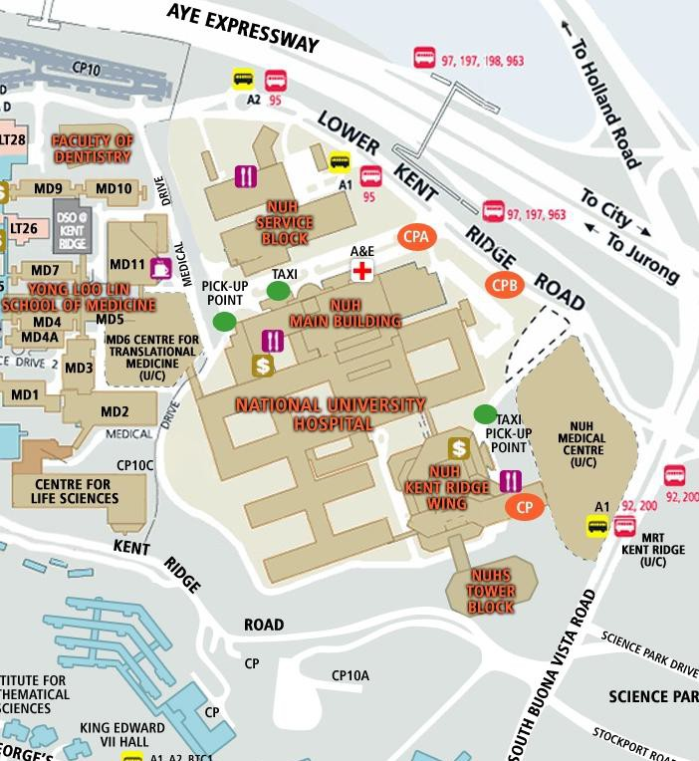Email: pynglee16@gmail.com

